**INTRODUCTION TO MATLAB**

**LAB # 01**



**Spring 2023**

**CSE301L Signals & Systems Lab**

Submitted by: **Ali Asghar**

Registration No. : **21PWCSE2059**

Class Section: **C**

“On my honor, as student of University of Engineering and Technology, I have neither given nor received unauthorized assistance on this academic work.”

Submitted to:

**Engr. Sumayyea Salahuddin**

Date:

**March 3, 2023**

**Department of Computer Systems Engineering**

**University of Engineering and Technology, Peshawar**

## Lab Objective(s):

Objectives of this Lab are;

* Built in Matrix Functions
* Indexing Matrices
* Sub Matrices
* Matrix element level operations
* Round Floating Point numbers to Integers

## Task # 01:

Write a program to generate a new matrix B from the matrix A given below such that each

column in the new matrix except the first one is the result of subtraction of that column from

the previous one i.e. 2nd new column is the result of subtraction of 2nd column and 1st column

and so on. Copy the first column as it is in the new matrix.

13 6 9

A = 1 4 8

2 8 17

### Code:

### Part a:

**Part b:**

### Output:

## Task # 02:

Generate two 2500 sampled random discrete time signals (1 dimensional) using rand() function

i.e. rand(1, 2500). Write a program to add the two such random signals together using simple

vector addition.

### Code:

**Equation 5:**

### Output:

**Equation 1:**

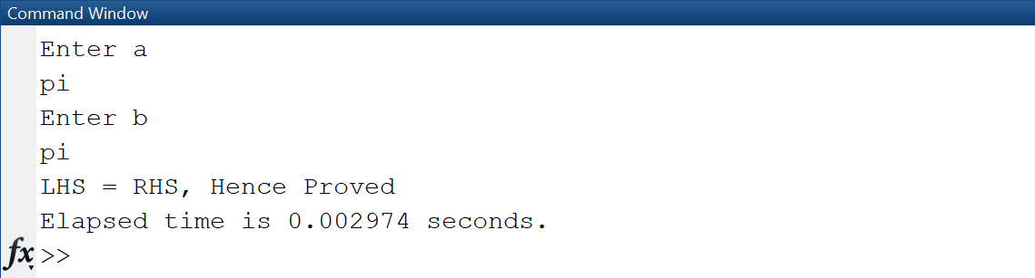

**Equation 2:**

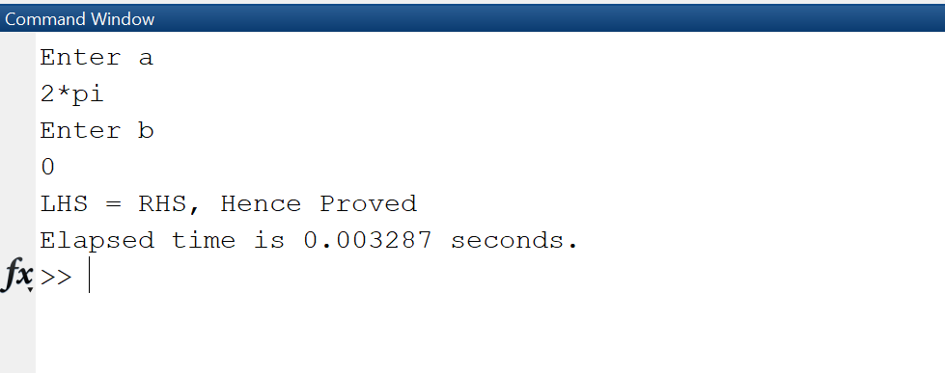

**Equation 3:**

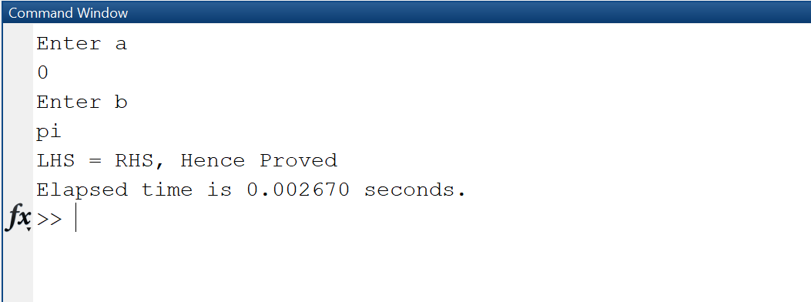

**Equation 4:**

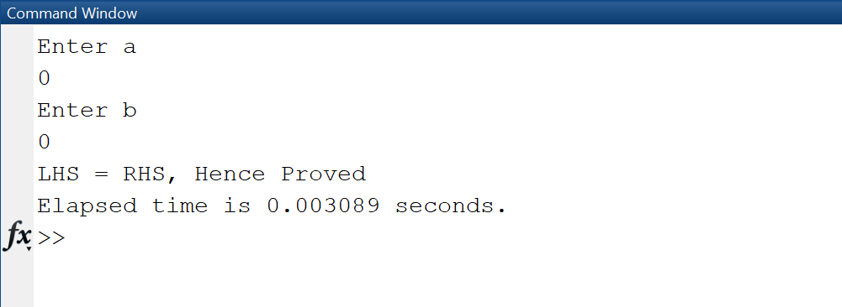

**Equation 5:**

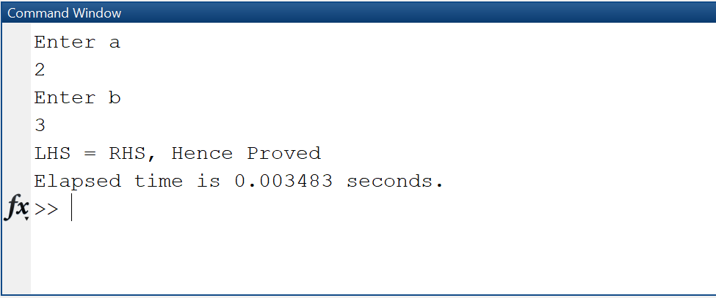

## Task # 03:

Write a CGPA Calculator program using M-File: Design a transcript for your second semester

result i.e. take grade points and credit hours of each subject as input from user and store in

variables. Take product of each subject grade points with its credit hours and divide by total

credit hours in order to evaluate CGPA. Show the results in the form of well designed transcript

using disp and input commands. Use the following table to display equivalent grades for each

grade point:

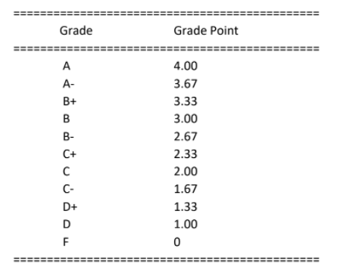

### Code:

### Output:

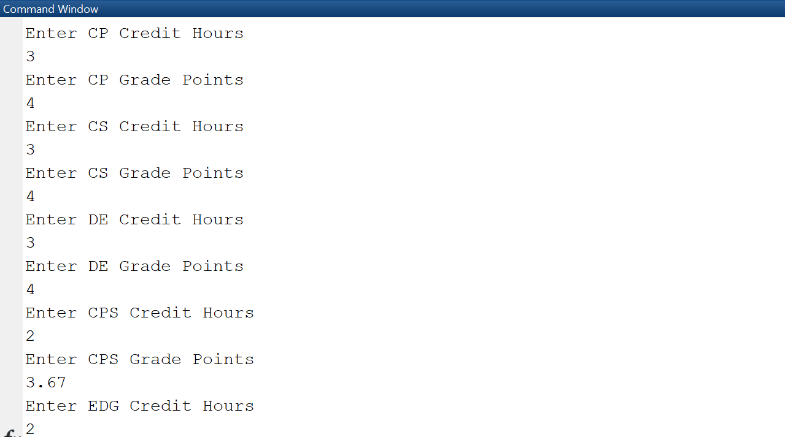

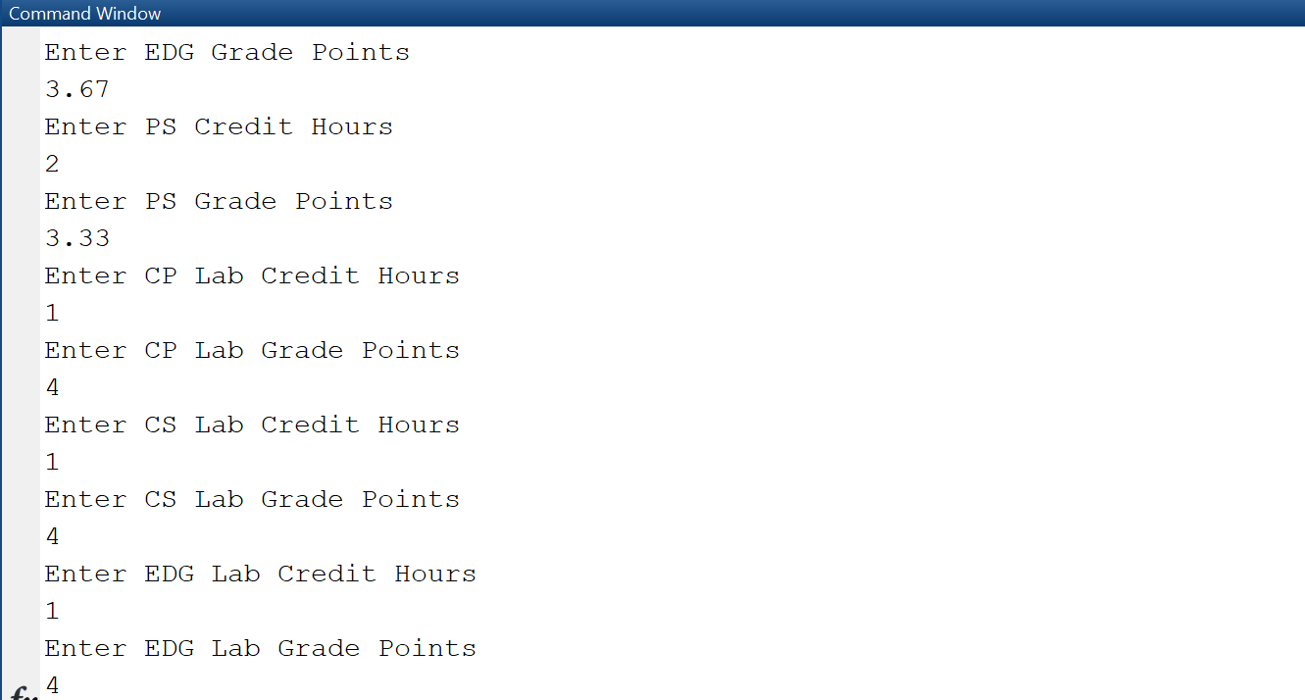

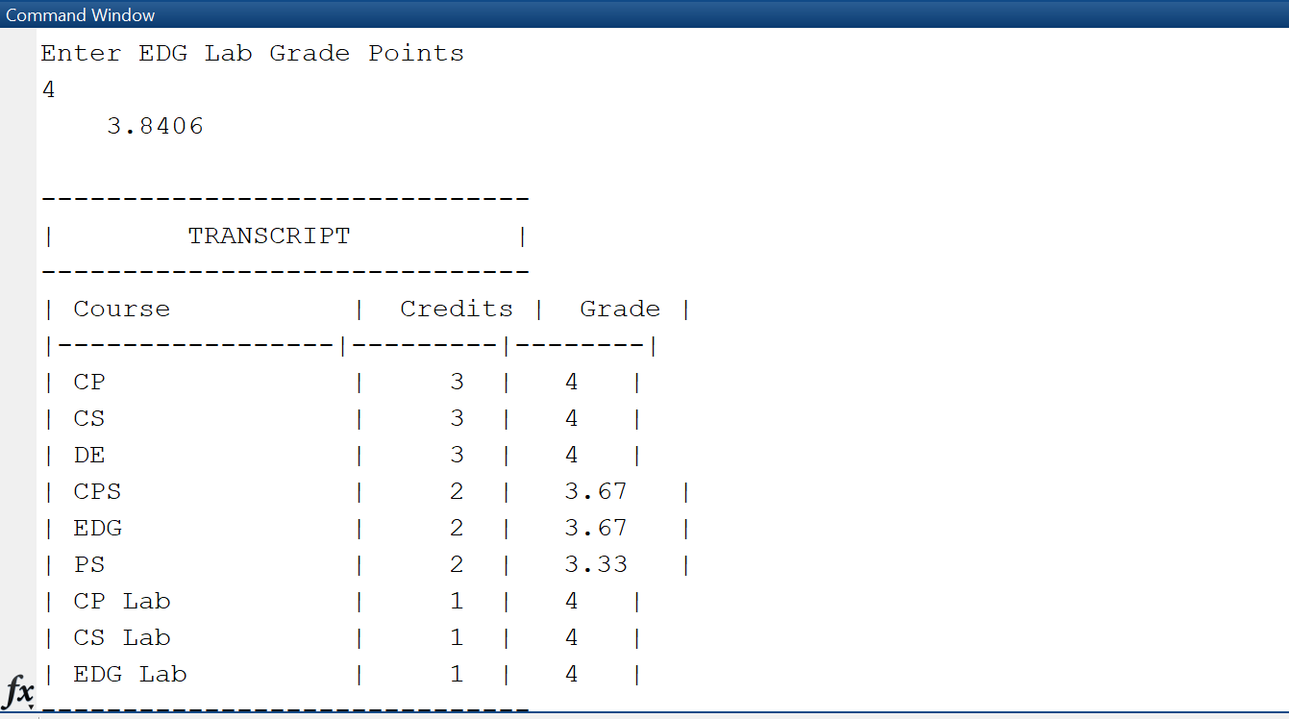

## 

## Task # 04:

Write a simple code to swap the values of two variables of double type using M-file. Create the

logic in such a way that no third variable is used. Show the etime for this code.

### Code:

### Output:

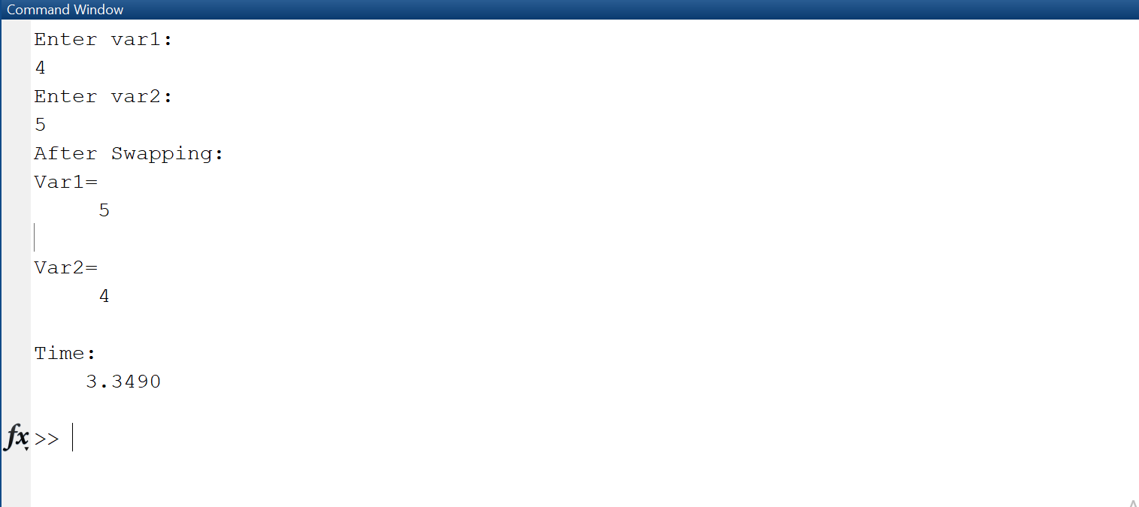

## Task # 05:

Implement the Pythagoras theorem in MatLab that takes input from the user.

### Code:

### Output:

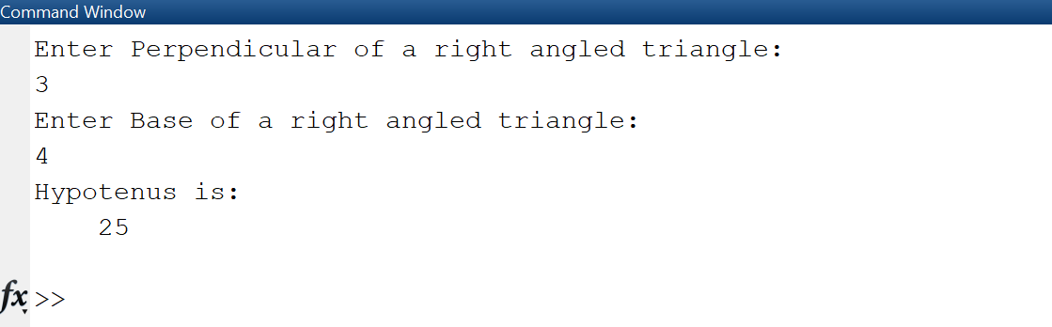

## Task # 06:

Implement a temperature conversion scenario in MatLab that takes the temperature from the user in Fahrenheit and displays the output in Centigrade.

### Code:

### Output:

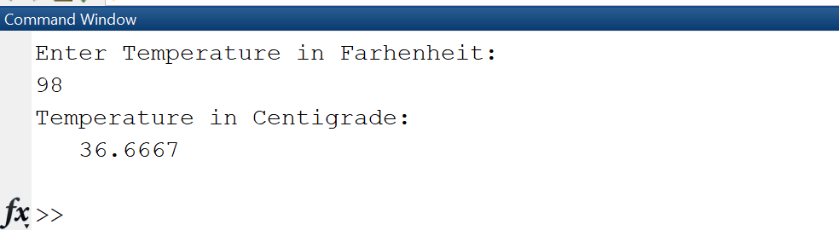

## Task # 07:

Devise an algorithm in MatLab that takes ten inputs from the user and normalizes them between [0-1]. Hints: Find the pair-wise max (maxi) and min (mini) of ten numbers using the max and min built-in command. Find the normalized value for each input using formula **(input-mini)/(maxi-mini).** Note: Do not use loops or if else structures.

### Code:

### Output:

